Project Design Phase-II
AI FAQ Assistant Technology Stack Architecture and Stack

Date | 28 September 2026
Team ID | SWTID-2026-8108
Project Name | AI FAQ Assistant
Maximum Marks | 4 Marks

Technical Architecture:
The Deliverable shall include the architectural diagram as below and the information as per the table1 & table 2
AI FAQ Assistant Technical Architecture

Guidelines:
Include all the processes (As an application logic / Technology Block)
Provide infrastructural demarcation (Local / Cloud)
Indicate external interfaces (third party API’s etc.)
Indicate Data Storage components / services
Indicate interface to machine learning models (if applicable)
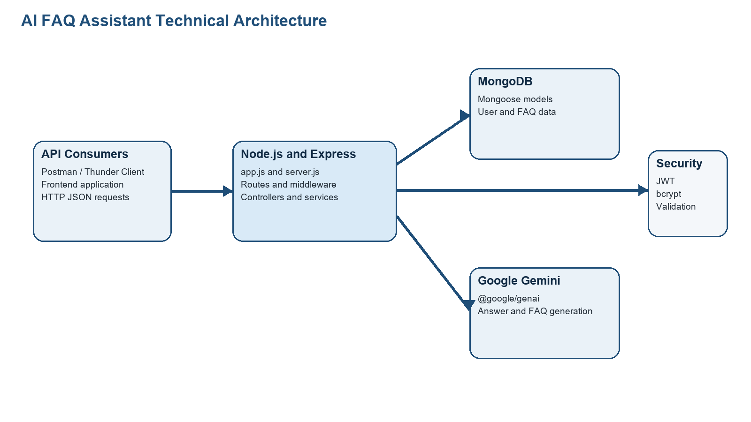

Table-1 : Components & Technologies:
S.No | Component | Description | Technology
- 1 | API consumers | Clients send JSON requests to the API and consume JSON responses. | Postman, Thunder Client, or a frontend application
- 2 | Application server | Configures the Express app, middleware, routes, database connection, and HTTP listener. | Node.js, Express.js, dotenv, cors
- 3 | Authentication logic | Registers users, logs them in, protects routes, and loads the current user. | jsonwebtoken, bcrypt, Express middleware
- 4 | FAQ business logic | Creates, retrieves, searches, updates, and deletes FAQ records while enforcing creator ownership. | Express controllers, Mongoose
- 5 | Validation and error handling | Validates request fields and returns standardized API errors. | Custom validation middleware and centralized error middleware
- 6 | Database | Stores User and FAQ documents with schema validation and relationships. | MongoDB and Mongoose ODM
- 7 | External AI API | Generates concise answers and structured FAQ question-answer pairs. | Google Gemini via @google/genai
- 8 | Testing interface | Sends repeatable requests for authentication, FAQ, search, and AI API routes. | Postman collection
- 9 | Infrastructure | Runs locally with environment-based configuration; can later be deployed to a Node.js-compatible host. | Local Node.js runtime; configurable deployment environment
- 10 | File storage | No separate file-storage component is required in the current API version. | Not applicable in current scope
- 11 | Machine learning capability | Uses a managed generative AI service rather than a locally trained model. | Google Gemini API

Table-2: Application Characteristics:
S.No | Characteristics | Description | Technology
- 1 | Open-source frameworks | The backend is modular and built with open-source JavaScript libraries. | Node.js, Express.js, Mongoose, cors, dotenv
- 2 | Security implementations | Passwords are hashed, private routes require JWTs, input is validated, and creators cannot change other users' FAQs. | bcrypt, jsonwebtoken, validation middleware, ownership checks
- 3 | Scalable architecture | MVC separation allows services and routes to grow without mixing concerns. | Controllers, models, routes, middleware, services
- 4 | Availability | The server port and database connection are configurable through environment variables. | dotenv and Express application server
- 5 | Performance | FAQ search uses MongoDB queries across relevant FAQ fields; API responses use lightweight JSON. | MongoDB, Mongoose, Express JSON responses

